NJ FCCLA Judge’s Information Form
March 20, 2024… Doubletree Hotel, Cherry Hill, NJ
Name
Title
Address
Home Phone # |  | Cell #
Email address
Employment – Company or school
Business e-mail
Current Position
Description
Retired | Yes ___ No___
Area of Expertise
Other interests
Who referred you to NJ FCCLA?
Are you affiliated with a particular Chapter? | Yes ___ No___ |  | If yes, which chapter?
Do you personally know any current FCCLA members? | Yes ___ No___ |  | If yes, who?

Due February 16th. Please send this form to: Mrs. Patricia DiGioia-Laird
NJ FCCLA State Adviser
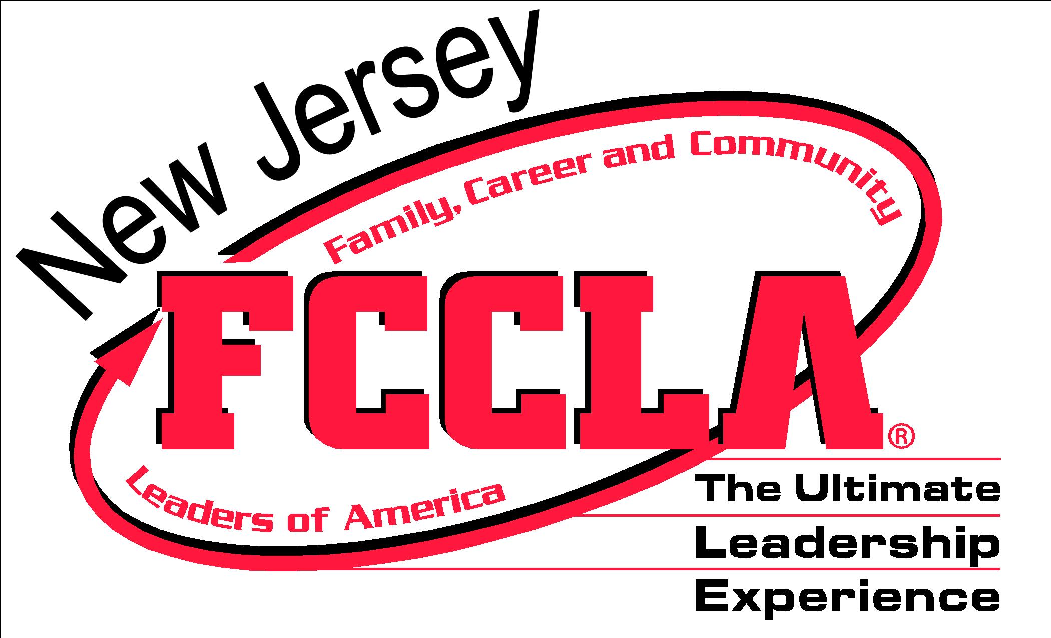
Email: njfccla@gmail.com
Phone: (732) 542-2862
Fax: (732) 494-4103

- Submitting this form does not guarantee participation. Judges are invited based on judge expertise and need and that is determined by student registration in the competitive events. Please look for an email from our office in mid to late February. Thank you!

