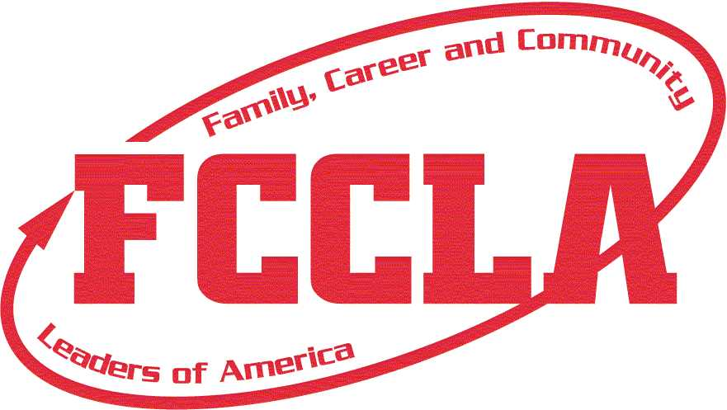
Due April 15, 2024 New Jersey

State Officer Application
Complete Type-Written Application and Return to:
Stacey Dworzanski NJ FCCLA State Director

J.P. Stevens High School
855 Grove Ave.
Edison, NJ 08820-2200

Name______________________________________ Date of Birth _____________ Grade_____________
Home Address ____________________________________ City_______________ Zip_______________
Candidate’s Home Phone________________________ Candidate’s Cell Phone _____________________
Candidate’s E-mail Address _______________________________________________________________

Name of Parent/ Guardian ________________________________________________________________

Parent/Guardian E-mail Address________________________________ Cell Phone __________________

Chapter_____________________________________________________ Region____________________

Adviser’s Name________________________ Adviser’s E-mail Address____________________________

Adviser’s Home Phone#_______________________ Adviser’s Cell Phone#_________________________

School__________________________________________ School Phone#_________________________

School Address________________________________________________________________________
An official transcript must be attached.

I certify that the unweighted scholastic rating of ______________ for the 2023-2024 school year is ______.
(First Name) (GPA)
____________________________________________________

Signature of Guidance Counselor Date

I give my permission and pledge my cooperation to assist and support my son/daughter, if elected, in performing the responsibilities of the office.

____________________________________________________

Signature of Parent/Guardian Date

I pledge my cooperation and will assist and support the candidate, if elected, in successfully performing the responsibilities of an FCCLA state office.

____________________________________________________

Signature of Chapter Adviser Date

____________________________________________________

Signature and Title of School Official Date

A written exam testing your knowledge of FCCLA will be administered at the mandatory pre-conference candidates’ meeting. Use the Chapter Handbook and the state and national websites to review facts about FCCLA. A score of 80% must be achieved in order to proceed as a candidate for state office. The pre-conference candidates’ meeting will be held Saturday, April 20th at 9:00 AM at John P. Stevens High School in Edison, NJ. Parent(s)/guardian(s) and chapter advisers are required to attend. Candidates will be interviewed by an election panel.

Do not attach additional papers or support materials! Additional pages will not be accepted!
Candidate’s Name__________________________________________________________________________
Please Check Your Region:
Grade Level ___________________

Cumulative G.P.A. ______________

Years in FCCLA ________________

□ Northern Region
□ Central Region
□ Southern Region

List the Family and Consumer Sciences Courses taken (One FCS course minimum must be completed before running for State Office.):

What FCS course do you plan to take during the 2024-25 school year? _______________________________

Why did you join FCCLA?

List the local, state, and national FCCLA offices, meetings, and committees in which you have been involved and any awards received.

Show further evidence of leadership abilities; include all offices held and community service activities outside of FCCLA.

Identify 2 ways you have used your leadership skills to encourage members and strengthen your chapter since the pandemic.

Identify one leadership quality that you possess and explain how this quality will make you an asset to the State Executive Council if elected.

If elected, how will you work to strengthen FCCLA at the state level (50-75 words)?

Adviser’s Recommendation: _________________________________
Please describe this student’s outstanding personal characteristics and abilities that make him/her a leader and ready to accept the duties and responsibilities of a state officer.

Signature of FCCLA Adviser Signature of Officer Candidate
Obligation of NJ FCCLA State Officer
- I understand the responsibilities of an FCCLA State Officer and have read and understand the bylaws of New Jersey FCCLA, Inc. and understand that a demerit system will be implemented upon election.

- I understand that I am obligated to attend and participate in the following:
  - 2024 State Leadership Conference where I could be installed as an officer.
  - 2024 FCCLA State Officer Leadership Training Seminars (June TBA, and/or July TBA)
  - 2024 FCCLA National Leadership Conference in Seattle, Washington (recommended for all; required for specific offices)
  - 2024 NJ FCS Professional Conferences
  - 2024 Fall Leadership Connection
  - 2024 National Fall Leadership Conference in (recommended)
  - 2025 NJ FCCLA Leadership Boot Camp
  - Eight to ten State Executive Council Meetings held throughout the year (many of which are on Saturdays)
  - 2025 State Leadership Conference where all state officer duties will be performed

- Failure to fulfill your term as an officer will result in reimbursing the state association for the cost of your training (Approximately $400) and the complete return of all FCCLA Officer related materials.

- I understand that I am to provide and wear state officer attire to the above meetings. (This includes wearing the designated outfit at the installation ceremony; white dress for female candidates or a black suit and red necktie for male candidates during the 2024 and 2025 New Jersey FCCLA State Leadership Conference). In addition, I understand that I am responsible for a $50 deposit for my uniform jacket and tie that is provided by NJ FCCLA, as well as the cost of purchasing additional uniform pieces as decided by the State Executive Council.

- I understand that there is no campaigning allowed at the State Leadership Conference. I will introduce myself to the membership in a one and a half-minute speech (90 seconds) for the candidates. I am not allowed to use any props before, during, or after my speaking. For the “Meet the Candidates” session, I will be expected to answer a minimum of one fact question and one situation question.

- I will establish an e-mail address for the purpose of FCCLA State Office communication. I will be responsible to check this e-mail daily and answer communications immediately. This e-mail address, in addition to a picture, may be posted on the NJ FCCLA website for communication with the membership. I will also maintain a professional image via the internet when using the approved social networking sites and abide by the state rules. Since the executive council communicates via phone at conferences, a mobile phone is a necessary communication tool.

- I will actively pursue membership development, corporate sponsorship, public relations, etc. for FCCLA.

- I will communicate all meeting times and expectations to my chapter adviser in a timely fashion as chapter advisers are expected to chaperone all FCCLA activities.

- I understand that as required, I have completed one FCS course and as a state officer I must be enrolled in an FCS course and maintain a minimum of a C+ grade in every subject and a minimum 3.0 GPA overall. I will submit copies of my report card each marking period. Attitude is equally important; I will abide by school rules.

- I understand that I must resign my office if I fail to fulfill the duties of the office and/or fail to attend meetings without a legitimate excuse or without notifying the New Jersey FCCLA State Adviser directly.

- I, ________________________, have read and understand the bylaws and responsibilities of the FCCLA State Officers. If elected, I pledge to fulfill the obligations of the office to which I am elected.

_____________________________ _________________________________ ____________
Signature of Applicant Signature of Parent/Guardian Date ____________________________________ ____________ No additional pages are accepted.
Signature of Chapter Adviser Date

